**Needs Assessment Questionnaire:**

*This document shows the questionnaire as the participant would see it.*

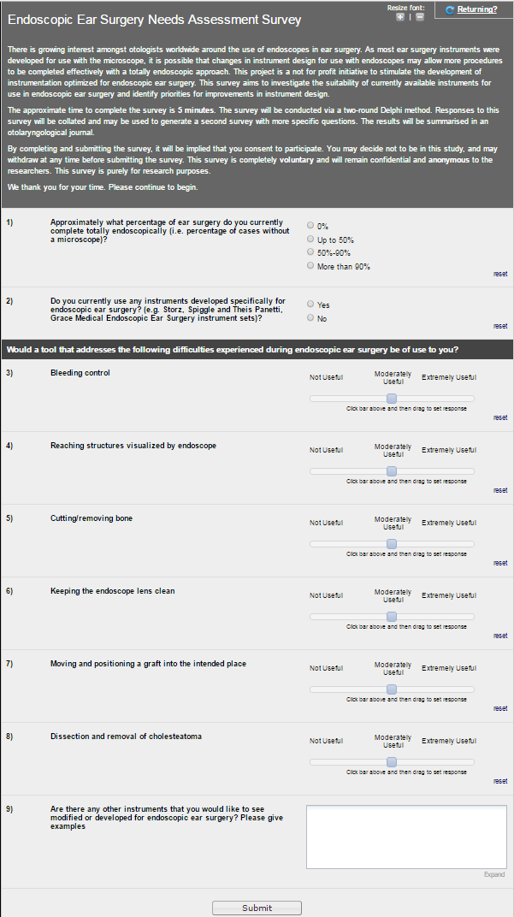

Below is the link to the survey.

<https://redcapexternal.research.sickkids.ca/surveys/?s=4J9N8H8JFL>